**Institute of Engineering & Management**

**Department of Computer Science & Engineering**

**Object Oriented Programming (IT) Lab for 3rd year 5th semester 2018**

**Code: CS594D**

**Date:** 24/07/18

**WEEK-3**

**Assignment-1**

**Problem Statement:** Create a class called boardparam that contans 2 instance variables length and width of the integer type and a void method for calculating surface area of the board, using parameterised method to create the object.

**Source code:**

import java.util.Scanner;  
  
class Main1  
{  
 public static void main(String[] args)  
 {  
 Scanner sc = new Scanner(System.in);  
 System.out.print("Enter the length: ");  
 int len=sc.nextInt();  
 System.out.print("Enter the length: ");  
 int wid=sc.nextInt();  
 BoardParam bp = new BoardParam();  
 bp.getValue(len, wid);  
 System.out.println("\nThe area of the board: "+bp.area());  
 sc.close();  
 }  
}  
  
class BoardParam  
{  
 int length, width;  
 void getValue(int n1, int n2)  
 {  
 length = n1;  
 width = n2;  
 }  
 int area()  
 {  
 return length*width;  
 }  
}

**Screen-Shot:**

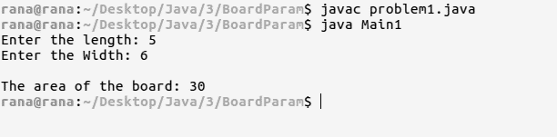

**Assignment-2**

**Problem Statement:** Create a class named shape. make circle, triangle, and rectangle as object of the shape class and calculate their area by concept of method overloading.

**Source code:**

import java.util.Scanner;  
import java.lang.Math;  
  
class Main2  
{  
 public static void main(String[] args)  
 {  
 Scanner sc = new Scanner(System.in);  
 System.out.print("Enter the shape: ");  
 String len=sc.next();  
 Shape sh = new Shape();  
 switch(len)  
 {  
 case "circle":System.out.print("Enter the radius: ");  
 double radius = sc.nextDouble();  
 sh.area(radius);  
 break;  
 case "rectangle":System.out.print("Enter the length: ");  
 double length = sc.nextDouble();  
 System.out.print("Enter the breadth: ");  
 double breadth = sc.nextDouble();  
 sh.area(length, breadth);  
 break;  
 case "triangle":System.out.print("Enter the 1st side length:");  
 double tri1 = sc.nextDouble();  
 System.out.print("Enter the 2nd side length:");  
 double tri2 = sc.nextDouble();  
 System.out.print("Enter the 3rd side length:");  
 double tri3 = sc.nextDouble();  
 sh.area(tri1, tri2, tri3);  
 break;  
 default: System.out.println("No such Shape!!");  
 }  
 System.out.println("The area is "+sh.area);  
 sc.close();  
 }  
}  
  
class Shape  
{  
 double area;  
 void area(double n1) { area = Math.PI*n1*n1; }  
 void area(double n1, double n2) { area = n1*n2; }  
 void area(double n1, double n2, double n3)  
 {  
 double s = (n1+n2+n3)/2;  
 area = Math.sqrt(s*(s-n1)*(s-n2)*(s-n3));  
 }  
}

**Screen-Shot:**

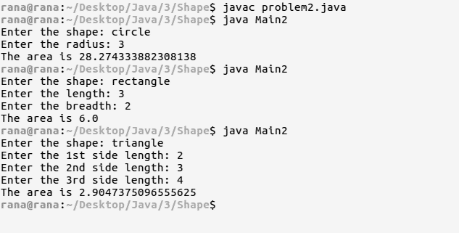

**Assignment-3**

**Problem Statement:** Write a java program to calculate the addition of two matrix class contains an integer 2D array with dimension n x m.

**Source code:**

import java.util.Scanner;  
  
class Main3  
{  
 public static void main(String[] args)  
 {  
 Scanner sc = new Scanner(System.in);  
 System.out.print("For 1st Matrix,\n Enter the no. of row: ");  
 int r=sc.nextInt();  
 System.out.print(" Enter the no. of col: ");  
 int c=sc.nextInt();  
 Matrix mtx1 = new Matrix(r,c);  
 mtx1.getValue();  
 System.out.print("For 2nd Matrix,\n Enter the no. of row: ");  
 r=sc.nextInt();  
 System.out.print(" Enter the no. of col: ");  
 c=sc.nextInt();  
 Matrix mtx2 = new Matrix(r,c);  
 mtx2.getValue();  
 System.out.println("\nThe result is:");  
 mtx1.add(mtx2);  
 mtx1.display();  
 sc.close();  
 }  
}  
  
class Matrix  
{  
 int row, col;  
 int mtx[][];  
 Matrix(int m, int n)  
 {  
 row = m;  
 col = n;  
 mtx = new int[row][col];  
 }  
 void getValue()  
 {  
 Scanner sc = new Scanner(System.in);  
 for(int i=0;i<row;i++)  
 {  
 for(int j=0;j<col;j++)  
 {  
 mtx[i][j] = sc.nextInt();  
 }  
 }  
 }  
 void add(Matrix mtx2)  
 {  
 if(row!=mtx2.row || col!=mtx2.col)  
 {  
 System.out.println("Not possible!!");  
 }  
 else  
 {  
 for(int i=0;i<row;i++)  
 {  
 for(int j=0;j<col;j++)  
 {  
 mtx[i][j] += mtx2.mtx[i][j];  
 }  
 }  
 System.out.println("Done!");  
 }  
 }  
 void display()  
 {  
 for(int i=0;i<row;i++)  
 {  
 for(int j=0;j<col;j++)  
 {  
 System.out.print(" "+mtx[i][j]);  
 }  
 System.out.println();  
 }  
 }  
}

**Screen-Shot:**

